Going to
Festival of The Girl Newcastle

My name is _____________________

I am ________________ years old.

On Saturday I am going to Festival of The Girl for a fun day out.
________________________________________
(insert name/s) will go with me to Festival of The Girl.

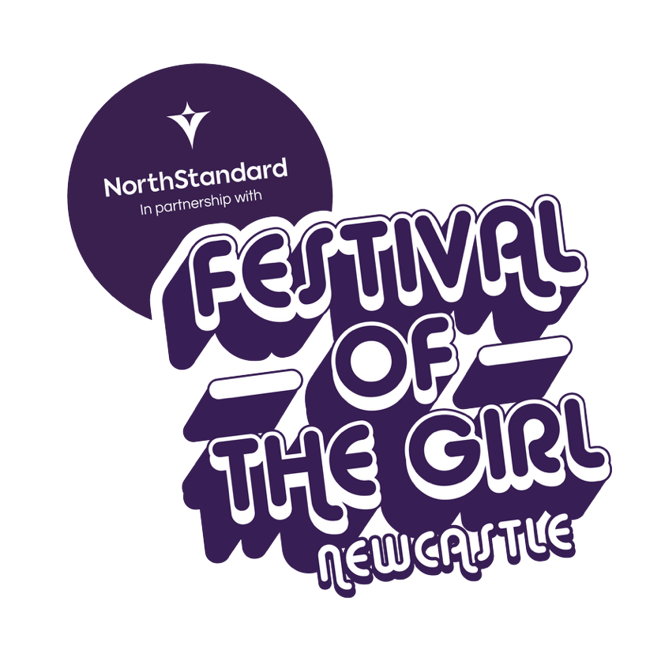
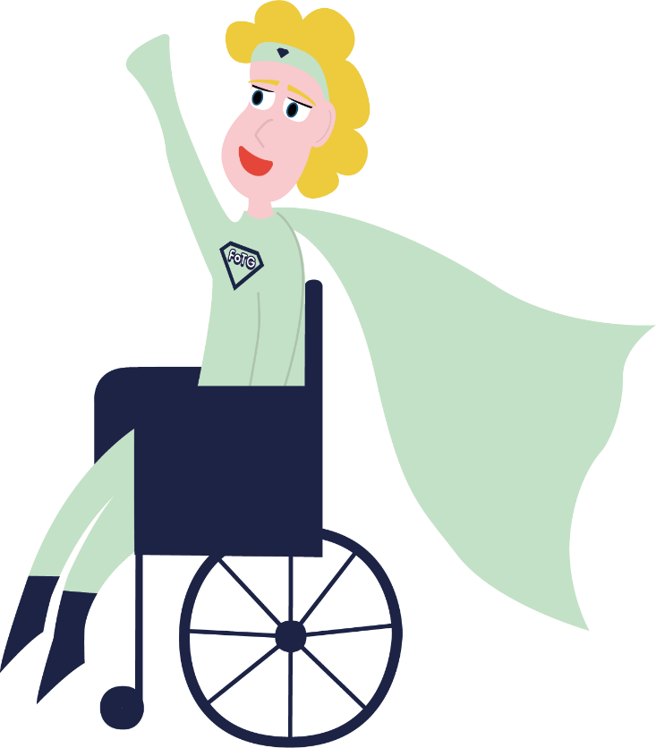

I will travel to Festival of The Girl by __________________________________________
When I arrive at Festival of The Girl Newcastle
I will go through the main entrance.

I might have to wait in a queue while they look at our tickets and check our bags.

That is ok.

I will be given a wrist band to wear if I want to.
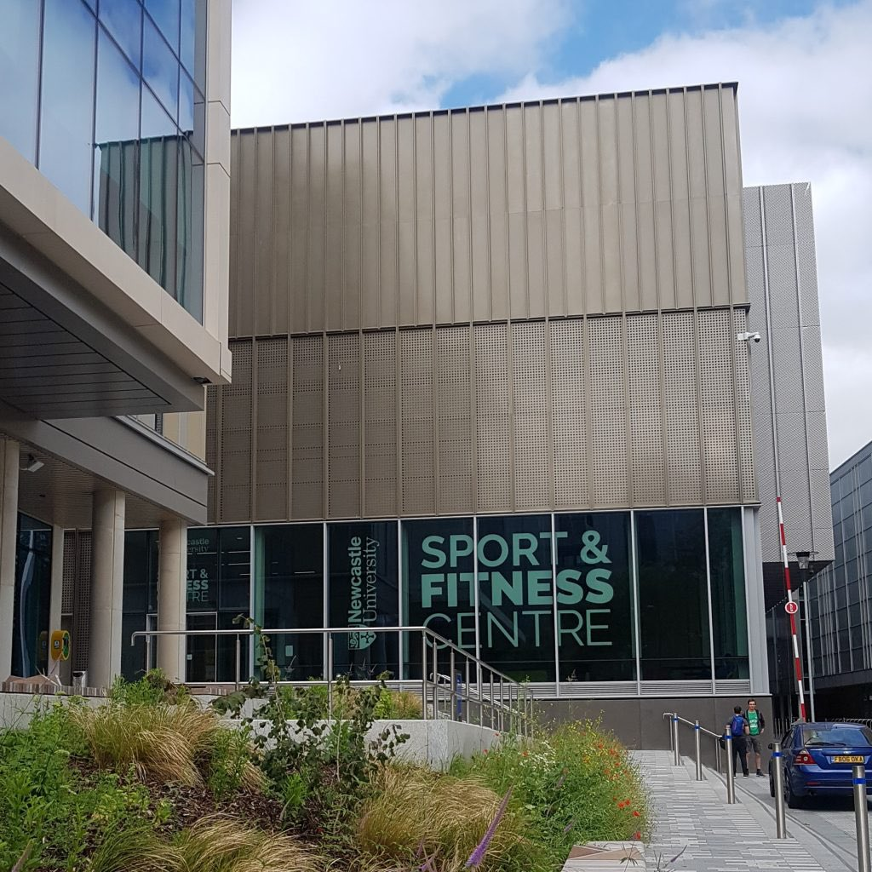
__________________________________________
__________________________________________
(insert travel plans)

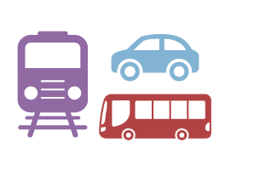

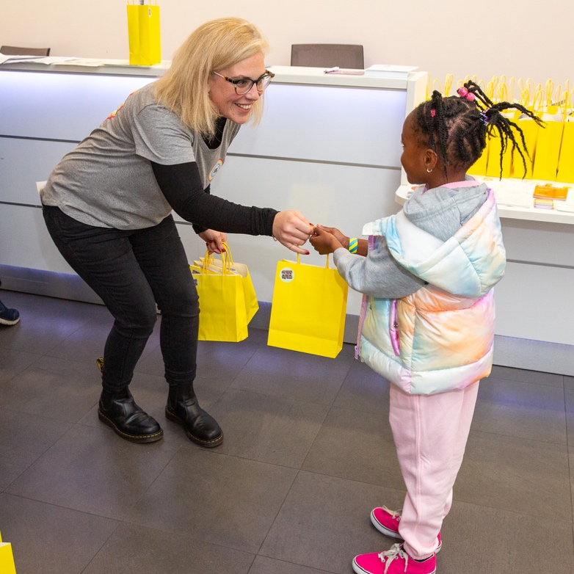
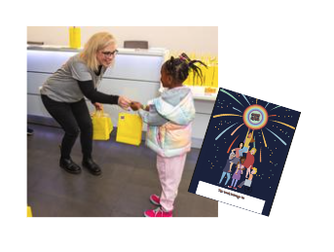
When I am in the festival there will be different activities I can try.

Here are some of the activities I can try if I want to:

- Boxing
- Playing rugby
- Trying a Virtual Reality headset
- Learning about being a pilot
- Having my face painted
- Playing football
- Making a vision board
- Building a bridge with spaghetti and marshmallows
- Dancing
- Learning about money

I will go through some doors and up some stairs or in a lift.

I will be given a goody bag and then I will enter the festival.

The festival might be busy with other people, but I will be ok. I will be with ______________________
(insert name/s).

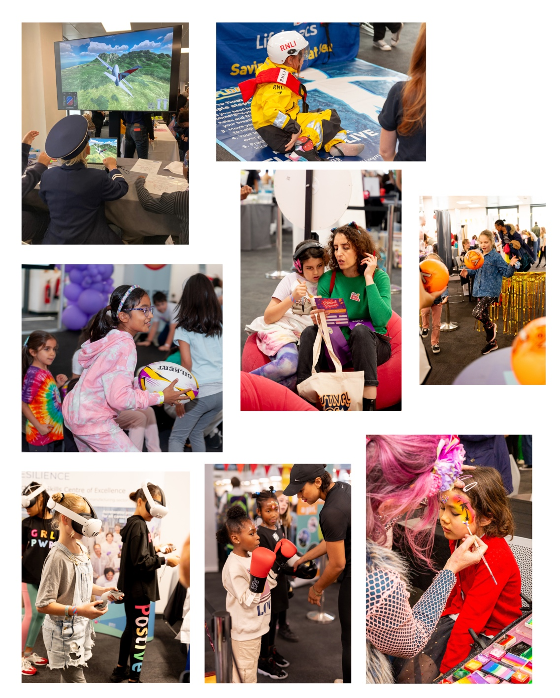
The activities that I would like to try are:
________________________________________

I can change my mind at the festival and try something different.

That is ok.

________________________________________

________________________________________

________________________________________

________________________________________

________________________________________

________________________________________

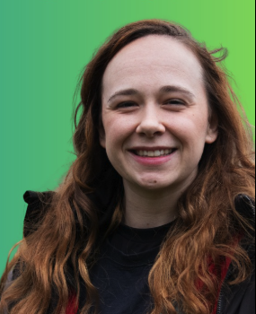
I can go upstairs and find the SEND space and meet Katie.

This is quiet space and has activities to help me feel calm and happy.

When I am there, I can also look over the festival from the balcony.

Although there will be lots going on I can take my time with ________________________________
(insert name/s) and have fun.

I can try something new if I want to.

If I don’t want to that is ok.

If I feel overwhelmed and worried that is ok.



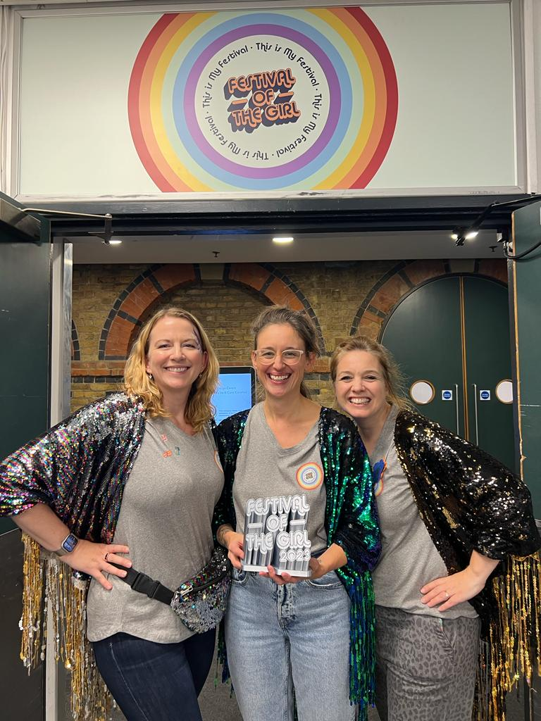
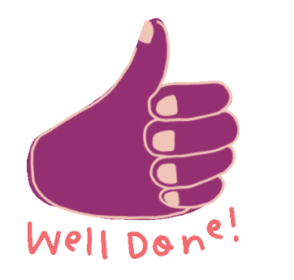
We can’t wait to see you on Saturday.

Jen, Abi and Laura.

When the festival is over, I will go home with my Festival of The Girl goody bag.

Going somewhere new is fun. I will learn new things. I will try something new if I want to.

Well done me!

When the festival is over, I will go home with my Festival of The Girl goody bag.

Going somewhere new is fun. I will learn new things. I will try something new if I want to.

Well done me!

When the festival is over, I will go home with my Festival of The Girl goody bag.

Going somewhere new is fun. I will learn new things. I will try something new if I want to.

Well done me!

